Jabil Requirement Document – Supply Chain Visibility Application

Alert Requirements

Authors: Ellen Chiu (IBM)

Document History

Document Location

This is a snapshot of an online document. Paper copies are valid only on the day they are printed. Refer to the author if you are in any doubt about the currency of this document.

Revision History

|  |  |  |  |  |
| --- | --- | --- | --- | --- |
| **Revision Number** | **Revision Date** | **Summary of Changes** | **Updated By** | **Email ID** |
| 0.1 | 09/27/2017 | Initial Version | Ellen Chiu | [yu.yen.chiu@ibm.com](mailto:yu.yen.chiu@ibm.com) |
| 0.2 | 10/02/2017 | Revised version after discussing with Paul, Jen, Tony, and Sadie | Ellen Chiu | [yu.yen.chiu@ibm.com](mailto:yu.yen.chiu@ibm.com) |
| 0.3 | 10/09/2017 | Revised version after discussing with Paul, Jen, Tony, Sadie, Babu, and Girish | Ellen Chiu | [yu.yen.chiu@ibm.com](mailto:yu.yen.chiu@ibm.com) |
| 0.4 | 10/16/2017 | Revised version with Girish’s feedback | Ellen Chiu | [yu.yen.chiu@ibm.com](mailto:yu.yen.chiu@ibm.com) |
| 0.5 | 10/19/2017 | Revised version based on 10/18, 10/19 call with Jen, Girish, and Sadie/Tom | Ellen Chiu | [yu.yen.chiu@ibm.com](mailto:yu.yen.chiu@ibm.com) |
| 0.6 | 10/24/2017 | Revised version based on 10/24 call with Jen, Paul, Girish and Sadie | Ellen Chiu | [yu.yen.chiu@ibm.com](mailto:yu.yen.chiu@ibm.com) |
| 0.7 | 11/01/2017 | Added missing points as per the discussion | Girish Limaye  Ellen Chiu | [gilimaye@in.ibm.com](mailto:gilimaye@in.ibm.com)  [yu.yen.chiu@ibm.com](mailto:yu.yen.chiu@ibm.com) |
| 0.8 | 11/09/2017 | Finalized version per discussion from 11/06-11/08 | Ellen Chiu | [yu.yen.chiu@ibm.com](mailto:yu.yen.chiu@ibm.com) |
| 0.9 | 11/09/2017 | Finalized version per discussion from 11/06-11/09 | Girish Limaye  Ellen Chiu | [gilimaye@in.ibm.com](mailto:gilimaye@in.ibm.com)  [yu.yen.chiu@ibm.com](mailto:yu.yen.chiu@ibm.com) |
| 1.0 | 11/16/2017 | Update per Jen’s and Paul’s email on 11/13 and 11/14 | Girish Limaye  Ellen Chiu | [gilimaye@in.ibm.com](mailto:gilimaye@in.ibm.com)  [yu.yen.chiu@ibm.com](mailto:yu.yen.chiu@ibm.com) |
| 1.1 | 12/06/2017 | Update per SCV call on 12/06 that Paul agrees that Late Purchase Order and Late Purchase Order shall be part of Event-based Alert with Parameters | Ellen Chiu | [yu.yen.chiu@ibm.com](mailto:yu.yen.chiu@ibm.com) |

Approvals

This document requires the following approvals. Signed approval forms are on an approval sheet at the end of this document.

|  |  |  |
| --- | --- | --- |
| **Name** | **Email ID** | **Role** |
| Jen Foster | Jennifer_Foster@Jabil.com | PLM |
| Paul Docherty | Paul_Docherty1@Jabil.com | PLM |

Jen and Paul represents PLM of SCV application from Jabil to confirm the content below contains full requirements of alerts to be developed in IC2.0.

Contents

1. Introduction 4

1.1 Overview 4

1.2 References 4

1.3 Assumptions 6

2. Requirements & Pseudo Business Logic 7

2.1 Functional Requirements 7

2.2 Functional Specification 17

2.2.1 Preconditions 17

2.2.2 Actors 17

3. Visual Designs 18

3.1 Wireframes 18

3.1.1 Top 10 Report directed to Alert with Parameters Subscription 18

3.1.2 KPI Alert 19

3.1.3 KPI Alert with Parameters – Directed from Top10/Detailed Report 19

3.1.4 KPI Alert with Parameters – After Saving KPI Alerts with Parameters 20

3.1.5 KPI Alert with Parameters – After Clicking “Create New Alert” at Alert Subscription Page 20

3.1.6 KPI Alert with Parameters – Error Message 21

3.1.7 Event-based Alert with Parameters – Directed from Top10/Detailed Report 21

3.1.8 Event-based Alert with Parameters – After Saving Event-based Alerts with Parameters 21

3.1.9 Event-based Alert with Parameters – After Clicking “Create New Alert” at Alert Subscription Page 22

3.1.10 Event-based Alert with Parameters – Status Update 23

# Introduction

## Overview

This document describes the requirements that satisfies Jabil’s functional requirements for the Supply Chain Visibility not developed yet as of 10/04/2017 within Release 1.

## References

* Jabil Application Business Requirements v2.1 For Distribution

5.1.3 If the user desires to set an event-based alert, they will be provided with decision criteria regarding that event. (For instance, if they want to be notified when a particular item has been received, they will need to specify the part number, and potentially also the supplier ID and purchase order number.) Some data fields will be required; others may be optional. (In the same example, the facility may want to know when any of a particular part are received; or they may only want to know when that part is received from a particular supplier ID.)

5.1.4 If the user desires to set a KPI/ Metric level-based alert, they will need to select the metric or KPI; then set the level at which an alert is generated. It would also be appropriate to set the frequency with which the metric is monitored. (Hourly, daily, etc.) In most cases, simply setting the level is sufficient; but in some cases it may be desired to set the direction as well. (Did the metric rise to the alert level? Or did it fall?) The metric may need to be configured for a specific customer, supplier, Jabil site, or other parameter(s) as well.

* Elaboration Document Business Rules App3 UC5 DRAFT v9

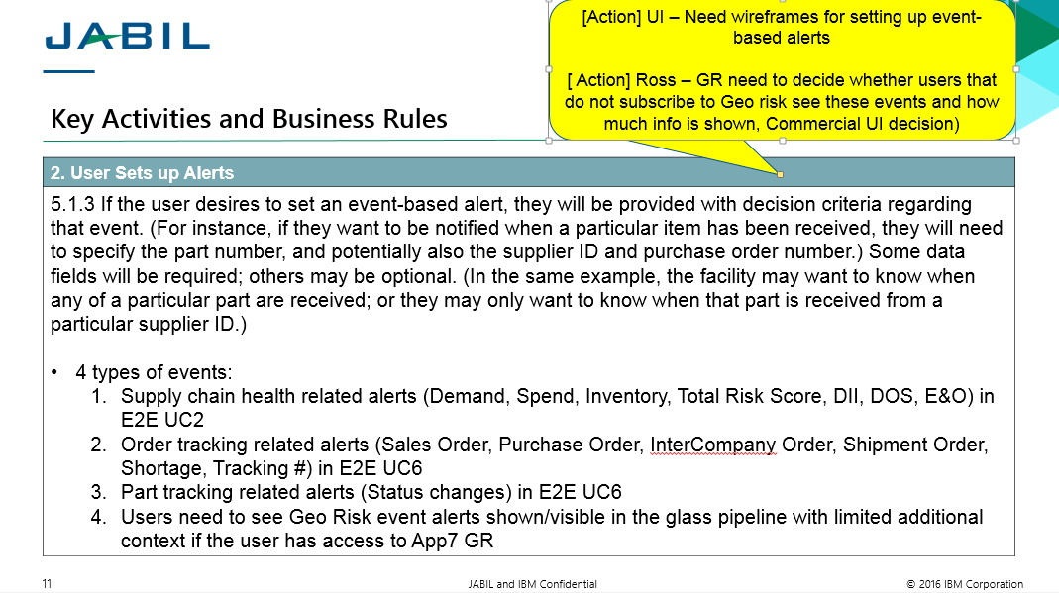

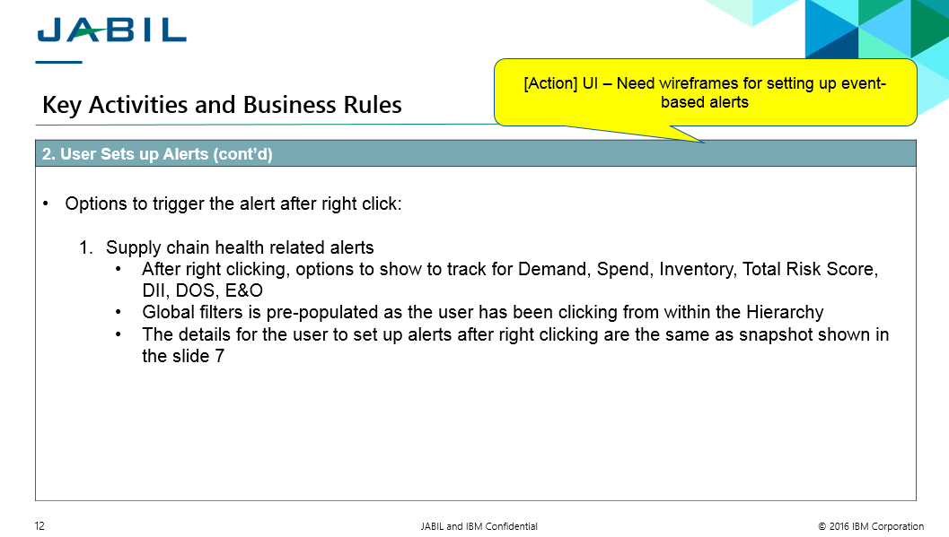

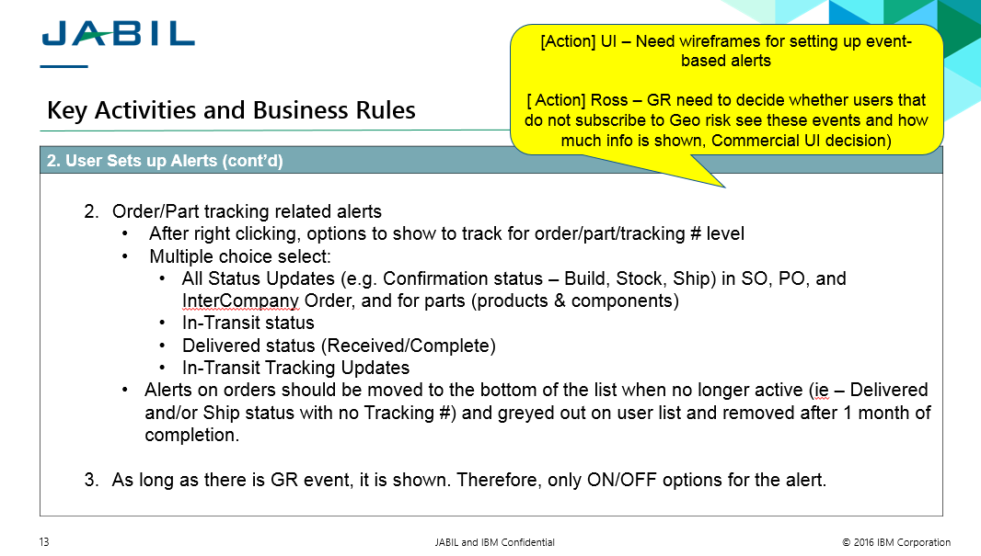

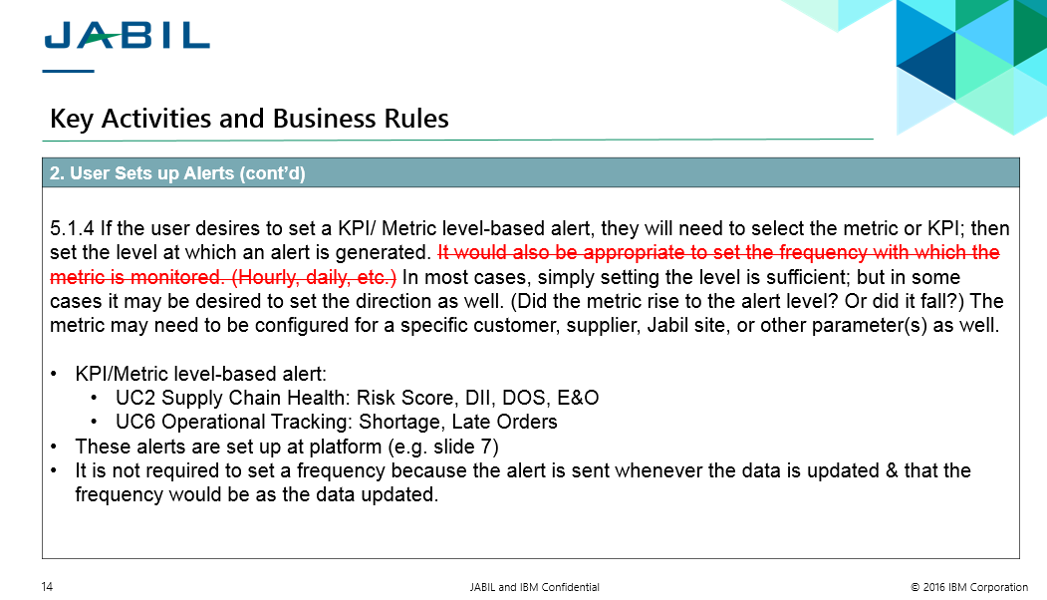

NOTE: Elaboration document was updated in Oct 2016. The details in Section 2 or what was agreed during UAT are more up to date. For example, Event Risk Alert was agreed during UAT 11/09 to show but the alert needs to be linked to the Hierarchy per ER requirements. DII should now always be referenced to as DOS(-) throughout all documentation. There is no on/off required for Event Risk Alerts in SCV.

* Acceptance Criteria (SCV UC5 5.1.3, 5.1.4)

|  |  |  |  |
| --- | --- | --- | --- |
| 22 | 5.1.3 | ALL USERS | able to set for a event-based tracking alerts the Order # (PO, SA, Intercompany, SO or Delivery/Shipment), Tracking#, or Part (Product/Assembly) or any Combination of these |
| 25 | 5.1.3 | ALL USERS | be able to set the Event Based alert to an active or inactive state. (e.g. Turn On/Off) |
| 26 | 5.1.4 | ALL USERS | be able to select the KPI/Metric and be presented with an option to set Alert Thresholds. |
| 38 | 5.1.4 | ALL USERS | be able to set the KPI alert to an active or inactive state. (e.g. Turn On/Off) |

## Assumptions

The following design has been developed based on the following assumptions. Any changes in the items below may require adjustments to this design.

1. Source data and ETL are available to support the requirements

# Requirements & Pseudo Business Logic

## Functional Requirements

Below are requirements requested by PLM (Jen and Paul) in Oct and Nov meeting as InControl 2.0 Release 1 5.1.3 and 5.1.4 Alert Requirements:

1. **Three entry points to subscribe alerts: (1) KPI-alert; (2) KPI-alert with parameters; (3) Event-based alerts with parameters**
   1. KPI Alerts: The user comes to this page directly to subscribe KPI alert, i.e. the KPI alert subscription page remains the same as implemented in R1 except adding toggles on the top.
   2. KPI Alerts with Parameters: The user is directed from SCV Detailed or Top 10 report by selecting the row and clicking “Create New Alert” to this page to subscribe an alert from the report or comes to User Profile – Alert Subscription directly to view the alert with parameters previously subscribed or create an alert with parameters directly at this page.
   3. Event-based alerts with parameters: The user is directed from SCV Detailed or Top 10 report by selecting the row and clicking “Create New Alert” to this page to subscribe an alert from the report or comes to User Profile – Alert Subscription directly to view the alert with parameters previously subscribed)--- This will replace the existing event alert screen.
2. **KPI-Alert Screen – Detailed Requirement**
   1. Add toggles to view other types of alert subscription added in this doc

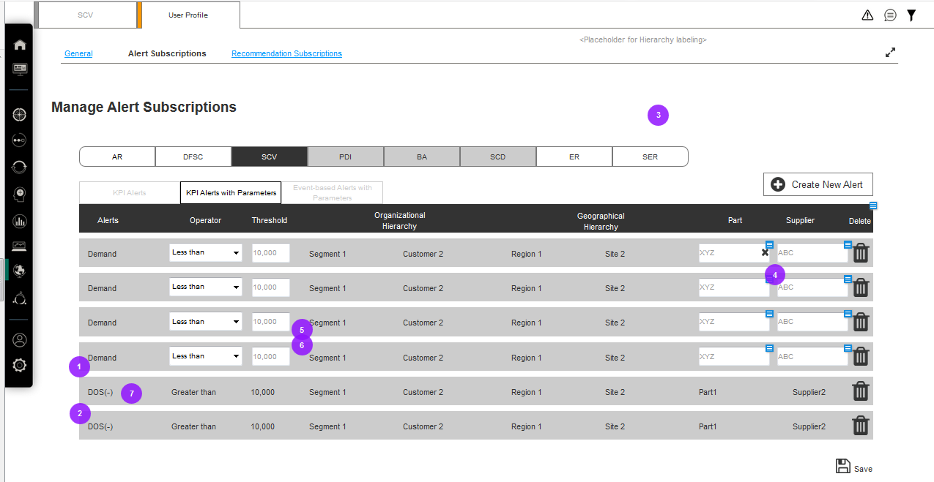

Toggles

* 1. There is no any change in the existing KPI alert subscription in subscription side/scheduler logic or notification display side (Other CR may impact this page as a separate topic; e.g. the content may be feasible to change as part of UAT-86; e.g. CR 125 will address material shortage).

1. **KPI-Alert with Parameters – Detailed Requirement**

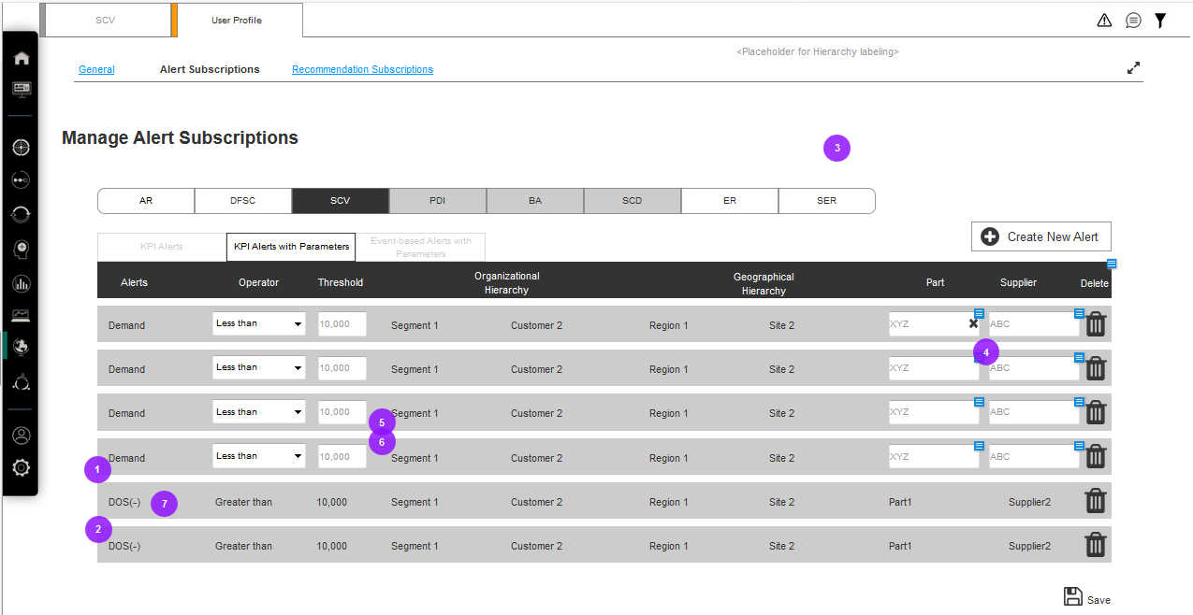

.

* 1. Two entry points to create an alert with parameters
     1. from Detailed and Top 10 reports in
     2. from User Profile – Alert Subscription
  2. The alert is subscribed when the below field is pre-populated or filled and saved: Alert, Operator, Threshold, Organizational Hierarchy, Geographic Hierarchy, Part and/or Supplier.
  3. From Detailed and Top 10 report
     1. If user is subscribing through details/top 10 of any of the KPIs (Demand, Inventory, Spend, Days of Supply <Dos(+)>, Days in Inventory <Dos(-)>, Excess & Obsolete <E&O>, ~~Late Purchase Order <LPO>, Late Sales Order <LSO>~~), then the screen will redirect to only KPI subscriptions with Parameters screen in a new tab next to the current SCV tab.
     2. Alert
        + Mandatory
        + Pre-populated KPI type (Demand, Spend, Inventory, DOS+. DOS-, E&O, ~~LPO, LSO~~) as the selected insight from SCV Application.
        + The user can’t change the value.
     3. Operator
        + Mandatory
        + A drop down list to be selected by the user

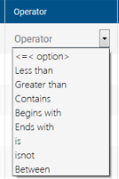

* + - * The by default value is “Operator” in grey.
      * The user must select the value to trigger the alert.
    1. Threshold
       - Mandatory
       - The by default value for Demand, Spend, Inventory, DOS +, DOS-, E&O, ~~LPO, LSO~~ is auto-populated from the application, i.e. the same KPI value in detailed and Top 10 report of the selected hierarchy.
       - The auto-populated value can be changed by the user.
       - The user must set the value to trigger the alert.
    2. Organizational Hierarchy
       - Mandatory
       - Pre-populated as the selected global filter from SCV application.
       - When coming from detail/top10 only hierarchy should be greyed out.
       - The user can’t change the value.
    3. Geographic Hierarchy
       - Mandatory
       - Pre-populated as the selected global filter from SCV application.
       - When coming from detail/top10 only hierarchy should be greyed out.
       - The user can’t change the value.
    4. Part
       - One out of part/supplier is mandatory.
       - Pre-populated value as the selected row(s) of the report from SCV application.
       - The user is allowed to clear the value but not allowed to change the value.
    5. Supplier
       - ~~Supplier text field will be enabled only for Late Purchase Order KPI~~. For other KPIs the supplier field will be greyed out.
       - Pre-populated value (if available) as the selected row(s) of the report from SCV application.
       - The user is allowed to clear the value but not allowed to change the value.
    6. It is not allowed to clear both part and supplier content, i.e. if the user clears the value in Part field, he/she can’t clear the value of the Supplier field.
    7. Delete
       - The user is able to delete any alert subscription row.
       - After clicking delete, no confirmation of deleting is required nor recovery of the subscription unless the user re-subscribe from SCV application.
    8. Reports as the source of generating KPI-alert with parameters
       - DOS (-) top 10 and detailed report
       - DOS (+) top 10 and detailed report
       - E&O top 10 and detailed report
       - Demand top 10 and detailed report
       - Inventory top 10 and detailed report
       - Spend top 10 and detailed report
       - ~~Late Sales Order top 10 and detailed report~~
       - ~~Late Purchase Order top 10 and detailed report~~
  1. From User Profile – Alert Subscription
     1. Progressive Filtering
        + The user must specify organizational and geographic hierarchy before filling in part or supplier
        + Progressive filtering doesn’t apply to Alert, Operator, and Threshold.
     2. Alert
        + A dropdown list to be selected by the user to specify KPI type (Demand, Spend, Inventory, DOS+. DOS-, E&O, Late Sales Order, Late Purchase Order)
        + The by default value is blank after the user clicks “Create New Alert” at this page.
     3. Operator
        + A drop down list to be selected by the user



* + - * The by default value is “Operator” in grey.
      * The user must select the value to trigger the alert.
    1. Threshold
       - Once user selects the alert names, the threshold should display the unit of measure (e.g. Count, Dollar, Days).
       - Threshold will have only numbers displayed.
       - No default value is populated. User should explicitly set the values.
       - The user must set the value to trigger the alert.
    2. Org hierarchy
       - Drop down list to be selected by the user
    3. Geo hierarchy
       - Drop down list to be selected by the user
    4. Part (number)
       - The by default value is blank.
       - Typehead search is required if both Part and Supplier field are blank.
       - If the user type Supplier filed first, then the candidate part numbers under the typehead search are filtered by this specific supplier.
       - If the user type Part filed first, then the candidate supplier names under the typehead search are filtered by this specific supplier.
       - Hierarchy selection should be done before typing supplier/part.
    5. Supplier (name)
       - The by default value is blank.
       - Typehead search is required if both Part and Supplier field are blank.
       - If the user type Supplier filed first, then the candidate part numbers under the typehead search are filtered by this specific supplier.
       - If the user type Part filed first, then the candidate supplier names under the typehead search are filtered by this specific supplier
       - Hierarchy selection should be done before typing supplier/part.
    6. It is not allowed to leave both Part and Supplier field blank. If the user leaves both blank, the warning message will show when the user clicks Save (see the wireframe for details).
    7. Delete
       - The user is able to delete any alert subscription row.
       - After clicking delete, no confirmation of deleting is required nor recovery of the subscription unless the user re-subscribe from SCV application.
  1. Save
     1. The user must click “Save” to successfully subscribe the alert.
     2. If the user leaves the page without saving, the alert is not subscribed even though all required field are filled.
  2. Create New Alert
     1. After “Create New Alert” is clicked, a new row is added on the top of the table entry without any pre-defined value.
  3. Part and Supplier may not be 1:1 relationship regardless of the entry points

|  |  |
| --- | --- |
| Part 1 | Supplier 1 |
| Part 1 | Supplier 2 |
| Part 1 | Supplier 3 |

|  |  |
| --- | --- |
| Part 1 | Supplier 1 |
| Part 2 | Supplier 1 |
| Part 3 | Supplier 1 |

* 1. Alert Content - KPI alerts and KPI alerts with parameters
     1. [Lowest level of Hierarchy] > [Lowest level of Geographic Hierarchy if selected] > Demand > 2.2K

"fill in metric" is now "fill in operator" “fill in threshold set” for Part Number "fill in part number (e.g. QQC75151611)" from "fill in Supplier name" per your alert settings.

* + 1. [~~Lowest level of Hierarchy] > [Lowest level of Geographic Hierarchy if selected] > Late Purchase Orders > 41~~

~~"fill in metric" is now "fill in operator" “fill in threshold set” for Part Number "fill in part number (e.g. QQC75151611)" from "fill in Supplier name" per your alert settings.~~

* + 1. Part number and Supplier information should be considered optional dependent upon the users selection and should NOT populate if no item is selected in the alert.
  1. Remove Pop-out screen to generate generic alert in SCV(available in R1 implementation from KPI reports); not to remove the screen in FFC All My Alert.

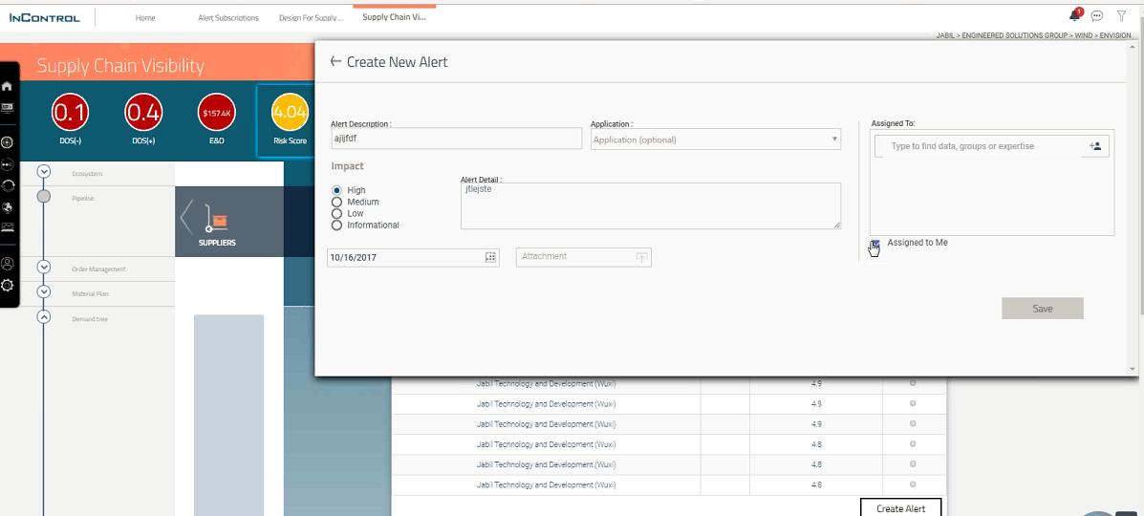

1. **Event-based alert with parameters screen**

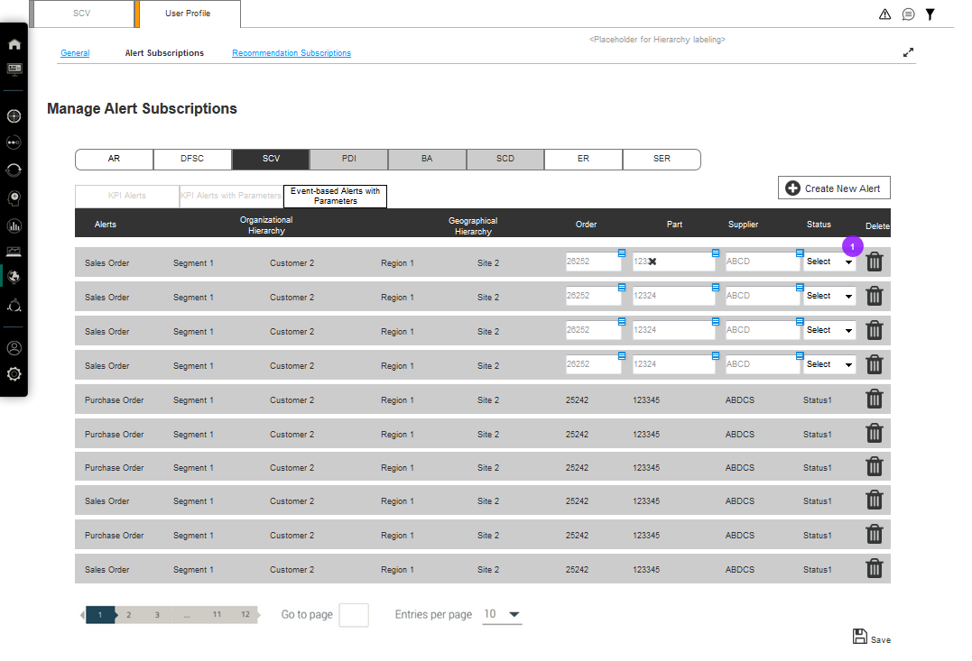

* 1. Two entry points to create an alert with parameters
     1. from Detailed and Top 10 reports in
     2. from User Profile – Alert Subscription
  2. The alert is subscribed when the below field is pre-populated or filled and saved: Alert, Organizational Hierarchy, Geographic Hierarchy, Part and/or Order and/or Supplier.
  3. The event alert status will always be checked based on the order number. So if only supplier and/or part is sent from UI then get the list of Order Number mapped to the supplier/part and check the selected status.
  4. From Detailed and Top 10 report
     1. Alert
        + Pre-populated Order type (Sales Order, Purchase Order, InterCompany Order, Shipment Order, Customer Order, Late Sales Order, Late Purchase Order) as the report type from SCV Application.
        + The logic should use the values as available in Detail or Top 10 report.
        + The user can’t change the value.
     2. Organizational Hierarchy
        + Pre-populated as the selected global filter from SCV application.
        + The user can’t change the value.
     3. Geographic Hierarchy
        + Pre-populated as the selected global filter from SCV application.
        + The user can’t change the value.
     4. Part
        + Pre-populated value as the selected row(s) of the report from SCV application.
        + The user is allowed to clear the value but not allowed to change the value.
     5. Order
        + Pre-populated value as the selected row(s) of the report from SCV application.
        + The user is allowed to clear the value but not allowed to change the value.
     6. Supplier
        + Pre-populated value as the selected row(s) of the report from SCV application.
        + The user is allowed to clear the value but not allowed to change the value.
     7. Interaction of Part, Order, and Supplier
        + It is minimum to keep part, order, or supplier value. It is not allowed to clear all of part, order, and supplier content, e.g. if the user clears the value in Order and Supplier field, he/she can’t clear the value of the Part field.
     8. Status
        + A dropdown list to be selected status subscription including Select all or single status for single or multiple selection. (see the wire for details)
     9. Delete
        + The user is able to delete any alert subscription row.
        + After clicking delete, no confirmation of deleting is required nor recovery of the subscription unless the user re-subscribe from SCV application.
     10. Reports as the source of generating event-based alert with parameters
         + Detailed and Top 10 Sales Order
         + Detailed and Top 10 Purchase Order
         + Detailed and Top 10 InterCompany Order
         + Detailed and Top 10 Shipment Order
         + Detailed and Top 10 Customer Order
         + Detailed and Top 10 Late Sales Order
         + Detailed and Top 10 Late Purchase Order
  5. From User Profile – Alert Subscription
     1. Progressive Filtering
        + The user must specify organizational and geographic hierarchy before filling in part, order or supplier.
     2. Alert
        + Order type is mandatory field selected by the user.
        + A dropdown list to be selected by the user to specify Event type (Sales Order, Purchase Order, InterCompany Order, Shipment Order, Customer Order, Late Sales Order, Late Purchase Order)
        + The by default value is blank after the user clicks “Create New Alert” at this page.
     3. Org hierarchy
        + Drop down list to be selected by the user
     4. Geo hierarchy
        + Drop down list to be selected by the user
     5. Part (number) The count of characters need to be verified based on the data available.
        + The by default value is blank.
        + Typehead search is required for part, order, and supplier field.
        + If one or two of part, order, and supplier field are filled, other remaining blank filed will show candidates accordingly. For example, if the user type Supplier filed first, then the candidate part numbers and order number under the typehead search are filtered by this specific supplier.
     6. Order (number)
        + The above rules for Part also apply for Order (number).
        + One order may have multiple material ID’s; one line item is one material ID.
     7. Supplier (name)
        + The above rules for Part also apply for Order (number).
        + Supplier value is available for purchase order, intercompany order, and (inbound) shipment order but not available for sales order, and (outbound) shipment order.
        + Supplier means any upstream supplier or Jabil site in Purchase order and InterCompany order given the data provided.
     8. It is not allowed to leave all of Part, Order and Supplier field blank. If the user leaves all blank, the warning message will show when the user clicks Save (see the wireframe for details).
     9. The no. of max. characters allowed for each field and the way to display the data will follow the style guide.
     10. The typeahead search is only available for open order.

|  |  |
| --- | --- |
| Order Type | Definition of “Closed” Order |
| (Late/Open) Sales Order | * If tracking number is available, the order is closed when all quantity is confirmed “delivered” to the customer. * If tracking number is not available, the order is closed when all quantity is confirmed “shipped”. |
| (Late/Open) Purchase Order | The order is closed when all quantity is confirmed “delivered” at Jabil site. |
| InterCompany Order | The order is closed when all quantity is confirmed “delivered” at Jabil site. |
| (Inbound) Shipment Order | The order is closed when all quantity is confirmed “delivered” at Jabil site. |
| (Outbound) Shipment Order | * If tracking number is available, the order is closed when all quantity is confirmed “delivered” to the customer. * If tracking number is not available, the order is closed when all quantity is confirmed “shipped”. |
| Customer Order | * If tracking number is available, the order is closed when all quantity is confirmed “delivered” to the customer. * If tracking number is not available, the order is closed when all quantity is confirmed “shipped”. |

* + - * NOTE: Tracking number availability: If outbound order doesn’t have valid tracking number, the ship status is last known status because there is no data to know when it is delivered to the customer side and there is no point to keep checking the status. Inbound orders will always have the delivered/completion status.
    1. Delete
       - The user is able to delete any alert subscription row.
       - After clicking delete, no confirmation of deleting is required nor recovery of the subscription unless the user re-subscribe from SCV application.
  1. Save
     1. The user must click “Save” to successfully subscribe the alert.
     2. If the user leaves the page without saving, the alert is not subscribed even though all required field are filled.

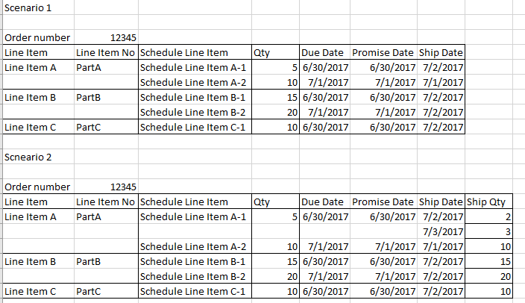

* 1. Event-based notifications at Order Line Item Level, not Schedule Line Item Level
     1. In Jabil world, both scenario 1 and Scenario 2 may exist.
     2. Blank order example
     + When an order is created, it can be blank PO with line item identified; but the due date/promise date, ship date and ship date and qty is not certain with the blank PO yet but will be defined later.
     + Below is the example how event-based alert will be generated if the alert is subscribed after the order creation while the schedule line is not defined yet.
     1. The event-based alert solution is provided given the ETL data availability and will be assessed when CR 143 is developed.
     + The data available in DB is at Line Item level. We shall be generating all the status notifications by calculating at line item level data.

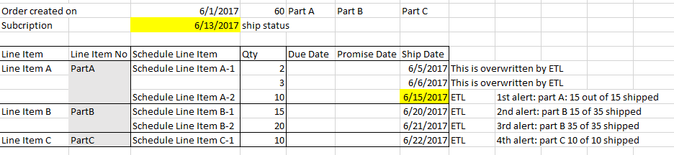

* 1. Alert Content
     1. Event-based alert with parameters

[Lowest level of Hierarchy] > [Lowest level of Geographic Hierarchy if selected] > Order Type > Order Number : Order Line Number

is now in "fill in status" status for "fill in current units" of "fill in total units" total units on "fill

in MM/DD/YYYY TIME" for part "fill in part number" from Supplier "fill in Supplier name"

Example 1: If the user was tracking PO 03030122708 for Customer Keysight (alert subscription settings)

Keysight > Purchase Order > 0303012278 : 0010

is now in Delivered status for 5 of 5 total units on 11/12/2017 10:17pm

Example 2: If the user was tracking PO 0303012279 for Supplier AVX at Customer Keysight for Americas Region (alert subscription settings)

Keysight > Americas Region > Purchase Order > 03030122708 : 0010

is now in Delivered status for 3 of 15 total units on 11/12/2017 10:17pm from Supplier AVX

* + 1. In-transit tracking

[Lowest level of Hierarchy] > [Lowest level of Geographic Hierarchy if selected] > Order Type > Order Number > Order Line Number

is now in "fill in Tracking system status" in "fill in Location (city, and then country if available)" at "fill in MM/DD/YYYY TIME" for part "fill in part number" from supplier "fill in Supplier name".

Example 1:

Keysight > Sales Order > 70030013809 : 0010

is now in Loading with DHL Express in Penang at 11/03/2017 10:22pm

Example 2:

Keysight > Purchase Order > 03030122708 : 0010

is now in Delivered at DHL Express in Penang at 11/12/2017 10:12pm from Supplier AVX

* + 1. Time format

Time format is based on FFC design and time availability may be impacted by CR 143.

* 1. Create New Alert
     1. After “Create New Alert” is clicked, a new row is added on the top of the table entry without any pre-defined value.
  2. Remove Pop-out screen to generate event-based alert (available in R1 implementation from KPI reports)

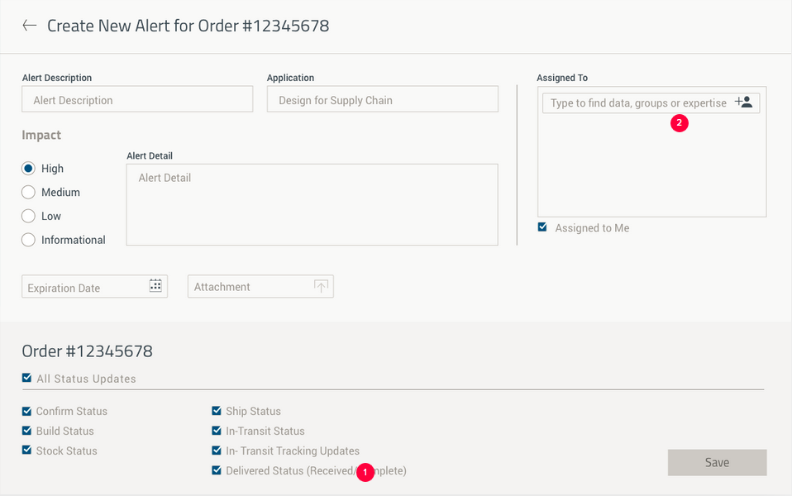

* 1. Remove alerts from SCV panels
     1. Each system-generated event-based alert is removed from SCV alert panel Display after 30 days of alert generation.

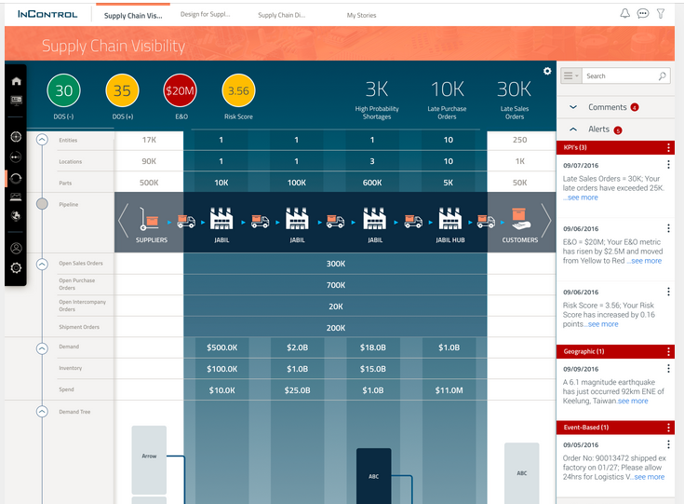

Each event-based alert is removed after 30-day of alert generation

* 1. Remove event-based alert subscription from User Profile – Alert subscription
     1. Each event-based alert subscription is removed from User Profile – Alert Subscription after 30 days of delivery completion.

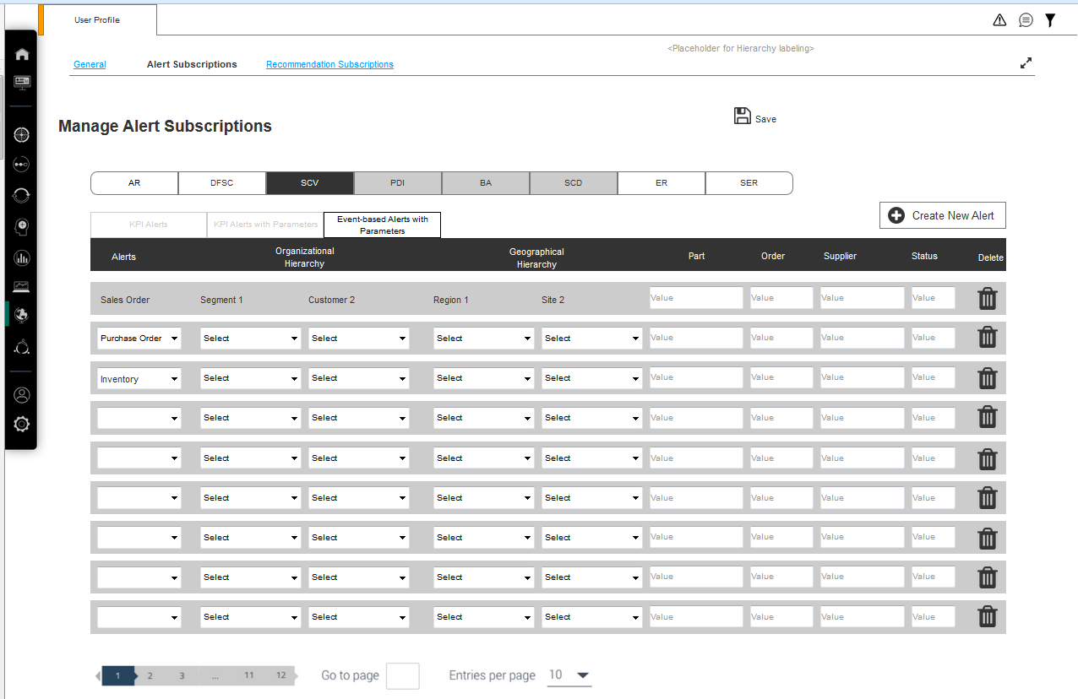

Each event-based alert subscription is removed after 30 days of delivery completion

1. **Requirements depending on other CR or defects**
   1. Below are requirements from PLM which IBM believes not part of 5.1.3 and 5.1.4, i.e. not part of this requirement document, and mostly FFC requirements.
   2. The ETA (Estimated to Arrive/Deliver) of below requirements depend on the resolution of other CR or UAT.

|  |  |  |
| --- | --- | --- |
| **#** | **PLM Requirement** | **CR or Other Dependency** |
| 1 | **Risk score with parameter alert subscription** - is available in Risk Management alert subscription with toggle view (Risk Alert and Risk Alert with parameters) | * CR to be submitted by Sergio * TBD by CR resolution |
| 2 | **FFC feature** - KPI alert with parameters and Event-based alert with parameters subscriptions have FFC attributes including:   * Export of alert subscriptions in excel * Filtering of alerts with table behavior * Change of Geographical Hierarchy drop down content. E.g. “Global” is invalid | * CR to be submitted by Sergio (UI change of the overall alert subscription change) * CR 239 (UAT-55) Redesign functions for tables (FFC) * TBD by CR resolution |
| 3 | **Tab refresh** – User experience is expected to be able to move between tabs and keep the data | * CR 210 WIP * FFC agreed Tab refresh with Jason as of 11/13 and Jason is in progress of aligning with all PLM * TBD by CR resolution |
| 4 | **Standardized alert content** across the applications | * CR to be submitted by Sergio (UAT-86) * Depend upon PLM to provide expected content * TBD by CR resolution |
| 5 | **Past status is not allowed to show in the notification** – (This is not doable due to ETL limitation) | * Depend up Jabil source data * Need Jabil data team to investigate * Need ETL change (CR to be submitted) * TBD by data and ETL assessment |

## Functional Specification

### Preconditions

The following pre-conditions are applicable:

* The IC 2.0 platform should be up and running
* The user’s subscription Supply Chain Visibility application

### Actors

The same users defined in BRD SCV chapters.

# Visual Designs

This section contains images of the wireframe screen designs for the above requirements.

## Wireframes

The wireframes are in AxShare at the following location:

**URL:**

[http://alonxn.axshare.com/#g=1&p=_uc2_5_6__sc_visibility_-_demand_-_top_10](http://alonxn.axshare.com/)

<http://alonxn.axshare.com/#g=1&p=user_profile_-_alert_subscriptions__scv__v2>

<http://alonxn.axshare.com/#g=1&p=user_profile_-_alert_subscriptions__scv__kpi_w_par>

<http://alonxn.axshare.com/#g=1&p=user_profile_-_alert_subscriptions__scv__kpi_w_par_1>

<http://alonxn.axshare.com/#g=1&p=user_profile_-_alert_subscriptions__scv__kpi_w_par_2>

<http://alonxn.axshare.com/#g=1&p=user_profile_-_alert_subscriptions__scv__kpi_w_par_3>

<http://alonxn.axshare.com/#g=1&p=user_profile_-_alert_subscriptions__scv__event_bas>

<http://alonxn.axshare.com/#g=1&p=user_profile_-_alert_subscriptions__scv__event_bas_1>

<http://alonxn.axshare.com/#g=1&p=user_profile_-_alert_subscriptions__scv__event_bas_2>

http://alonxn.axshare.com/#g=1&p=user_profile_-_alert_subscriptions__scv__event_bas_3

**Password:** CodeBlue2

### Top 10 Report directed to Alert with Parameters Subscription

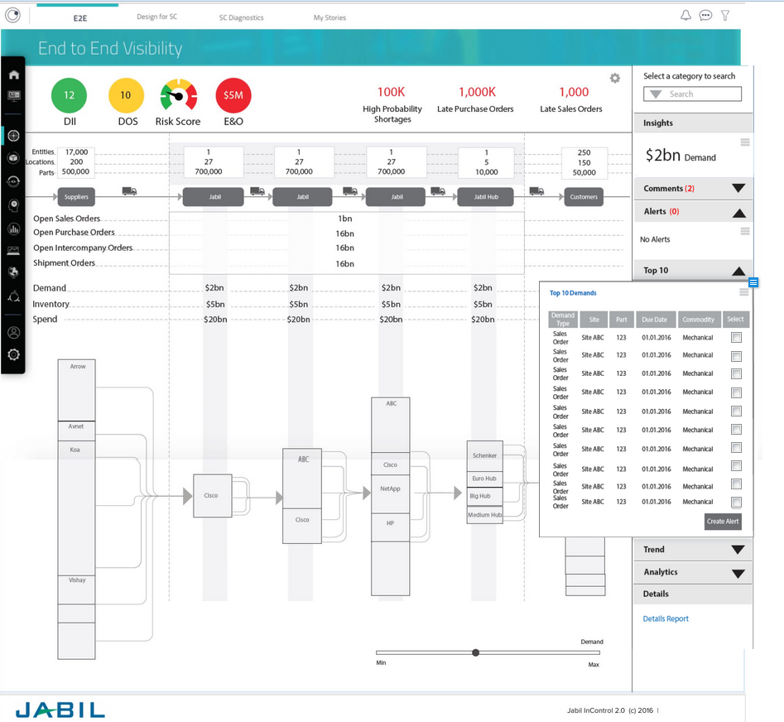

### KPI Alert

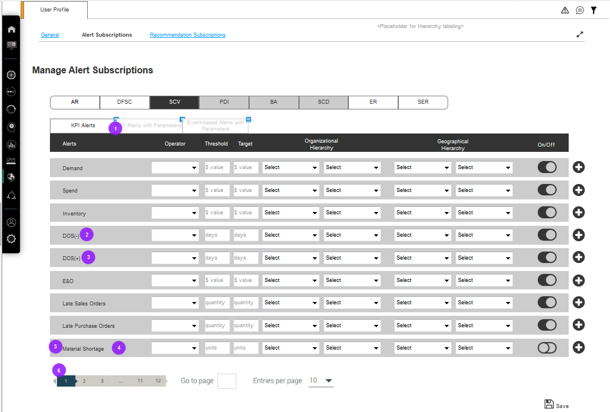

### KPI Alert with Parameters – Directed from Top10/Detailed Report



### KPI Alert with Parameters – After Saving KPI Alerts with Parameters

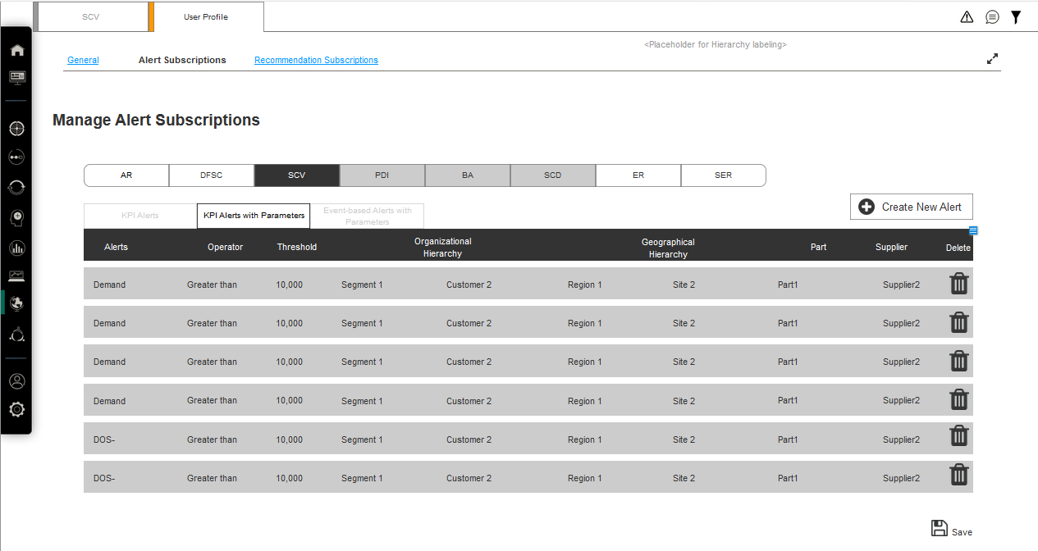

### KPI Alert with Parameters – After Clicking “Create New Alert” at Alert Subscription Page

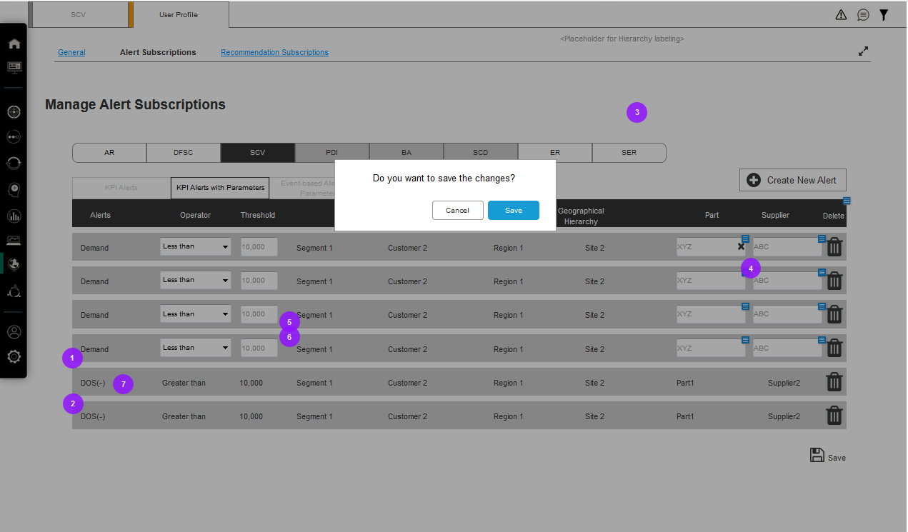

If the user clicks “Create New Alert” with unsaved alert subscriptions, this message will pop out.

* Click “Cancel”, go back to the subscription screen.
* Click “Save”, save previously-unsaved alert subscriptions (if the data is complete) and add new alert subscription screen row.
* Click “Save”, go back to the subscription screen with error message (if the data is incomplete)

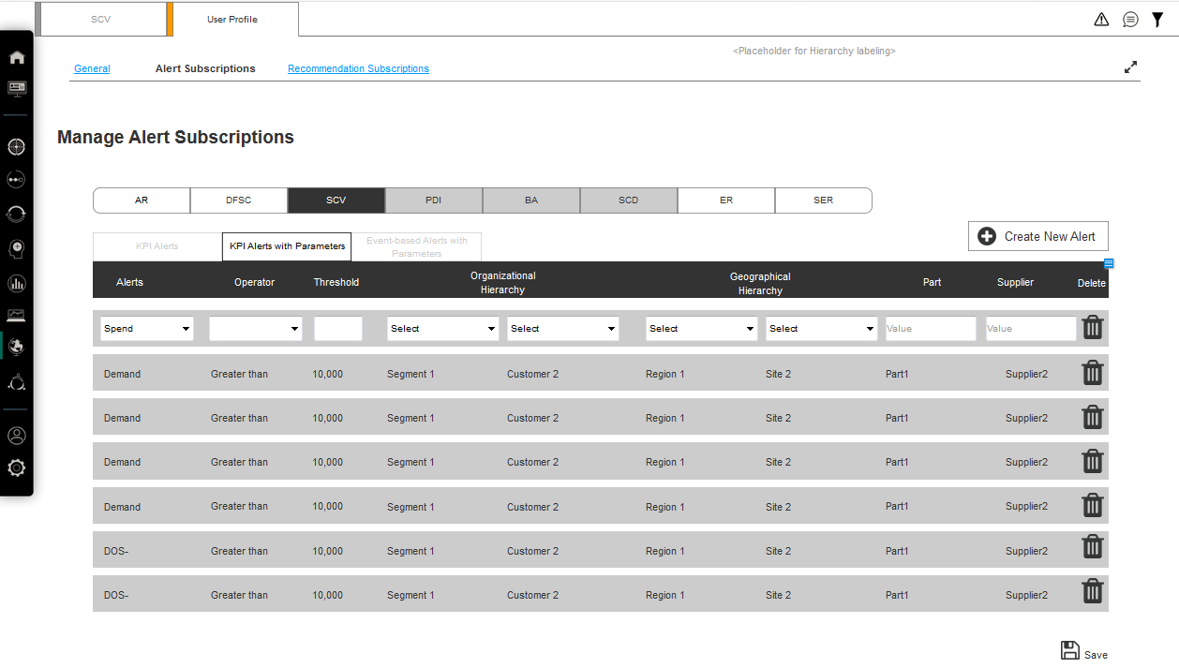

### KPI Alert with Parameters – Error Message

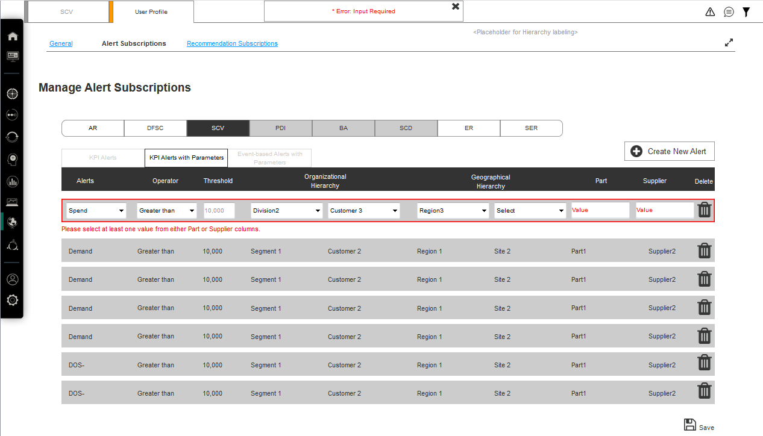

Whenever clicking “Save”, as long as the data is incomplete, a warning message will show.

### Event-based Alert with Parameters – Directed from Top10/Detailed Report



### Event-based Alert with Parameters – After Saving Event-based Alerts with Parameters

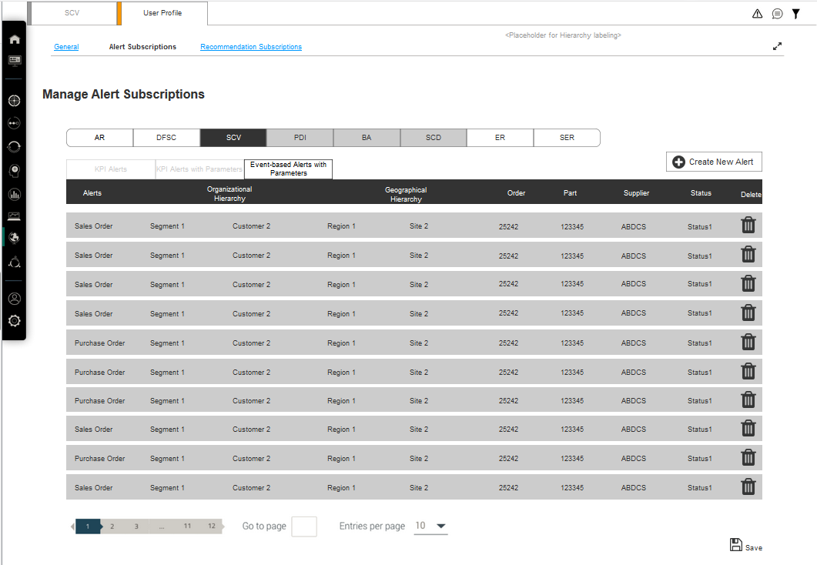

### Event-based Alert with Parameters – After Clicking “Create New Alert” at Alert Subscription Page

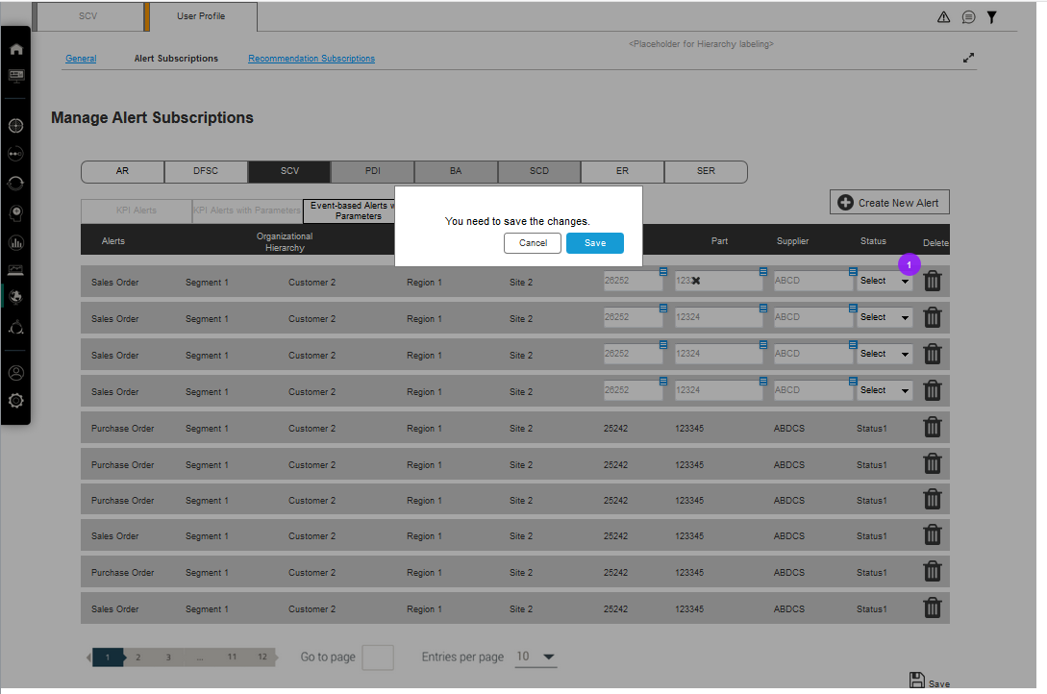

If the user clicks “Create New Alert” with unsaved alert subscriptions, this message will pop out.

* Click “Cancel”, go back to the subscription screen.
* Click “Save”, save previously-unsaved alert subscriptions and add new alert subscription screen row.
* Click “Save”, go back to the subscription screen with error message (if the data is incomplete)

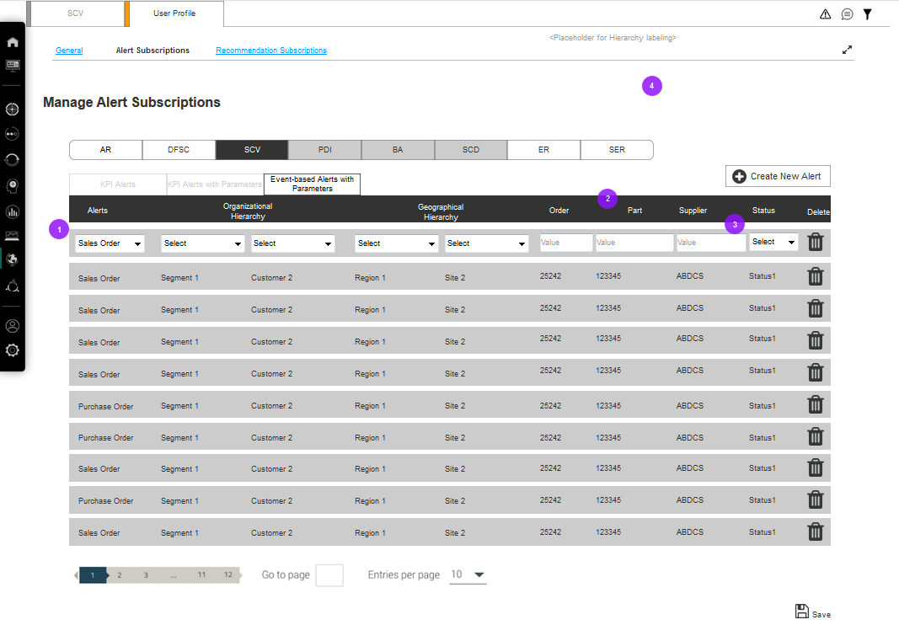

### Event-based Alert with Parameters – Status Update

